**Digital Image Processing or Signal Processing?**

**Electronics person called that signal processing.**

We take a signal that is 2-dimension domain than we process that some transformation over that signal. New terms for signal processing called digital Image Processing.

Take a Image --🡪 Convert that image in different forms of Images

1. **Resolution** - How many number of element does the picture contain

**Or**

**Number of Element**

**Example – What is resolution of Camra?**

Resolution refers to size of the display in terms of pixels. E.g. Resolution of 800×600 pixels means that the there are 800 pixels horizontally and 600 pixels vertically. So therefore there are a total of 480000 pixel in the display. Because this number is very unpractical to use, you can just divide it by a million to convert it into megapixels. So

480000/1000000 = .48 Mega Pixels

1. **Pixel – The value of element**
2. **Gray lable – Gray Lable is the value of pixel that have.**

Mathmatically image is matrix of some elements.

**Image Acquisition -> Image Enhancement - > Image Rotation - > Image Morphology -> Image Segmentation -> Image Recognition**

**What Is Image?**

**Image**

**Manipulation**

**How can we represent that image digitally?**

# Resolution

Image resolution is typically described in PPI, which refers to how many pixels are displayed per inch of an image.

Higher resolutions mean that there more pixels per inch (PPI), resulting in more pixel information and creating a high-quality, crisp image.

Images with lower resolutions have fewer pixels, and if those few pixels are too large (usually when an image is stretched), they can become visible like the image below.

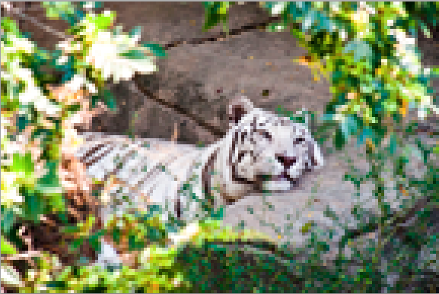

When you change the resolution of an image, you are saying how many pixels you want to live in each inch of the image. For example, an image that has a resolution of 600 ppi will contain 600 pixels within each in of the image. 600 is a lot of pixels to live in just one inch, which is why 600ppi images will look very crisp and detailed. Now, compare that to an image with 72ppi, which has a lot fewer pixels per inch. As you've probably guessed, it won't look nearly as sharp as the 600ppi image.  
  
Resolution rule of thumb: When scanning or photographing, always try and capture the image at the largest resolution/quality.

Why?

It's better to have more information than not enough! It's much easier for image editing applications, like Photoshop, to discard any unwanted image information (reducing the size of an image) than it is to create new pixel information (enlarge an image).

**Resolution Vs Pixel Density**

Most of the entertainment gadgets or devices that we use has display or screen as a primary device. Some of the primary examples are televisions, computer monitors and smartphones. What makes a display to have more quality? Is the display  size alone matters. NO! We have two main technical properties of display, **Resolution** Vs **Pixel Density** which decides its cost and quality. The term quality refers to the sharpness of the content on the display. We will see the basic overview of the technical terms and get into how to choose between displays with different resolution and pixel density. I will be using the terms “display” and “screen” which refers to any display(either a television display or computer monitor or even smartphone displays).

Pixel

      It is the smallest element that can be displayed on a screen. To be more simple, it is just a single dot on a display or a screen.

Resolution

      Usually displays are measured in size(in centimeters and inches). Here we only measure the diagonal size and not the horizontal or vertical size of the screen. There is also another important property of display which is the resolution. Resolution refers to size of the display in terms of pixels. E.g. Resolution of 800×600 pixels means that the there are 800 pixels horizontally and 600 pixels vertically. So therefore there are a total of 480000 pixel in the display. Because this number is very unpractical to use, you can just divide it by a million to convert it into megapixels. So

480000/1000000 = .48 Mega Pixels

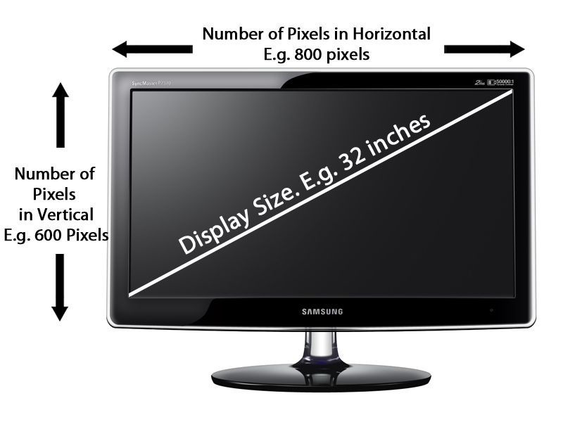

**Resolution is just the number of pixels on the display and this property alone does not measure the quality of display.**

Pixel Density

      Many of us are not aware of the importance of Pixel Density in displays. It is the thing which describes the sharpness and clarity. Pixel Density is usually measured in PPI (Pixels Per Inch) which refers to number of pixels present per inch on the display. Higher the pixel density higher is the sharpness of the content. Pixel Density is calculated based on the resolution and size of the display.

**Pixel Density= Root((Horizontal Number of Pixel^2) + (Vertical Number of Pixel^2))/Screen Size**

[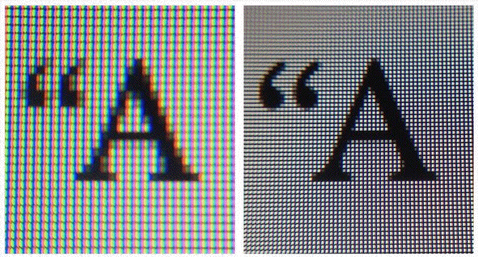](http://teknosrc.com/wp-content/uploads/2013/12/Pixel-Density-Comparison-of-Displays-with-Different-Resolution.gif)

Pixel Density – Comparison of Displays with Different Resolution

      Consider the above image. The alphabet “**A**” on the left is displayed on screen(32 inch display) with lower resolution. The alphabet “**A**” on the right is displayed on the screen(32 inch) with higher resolution which delivers better sharpness.

“Resolution or Display Size  
Which is important?”

[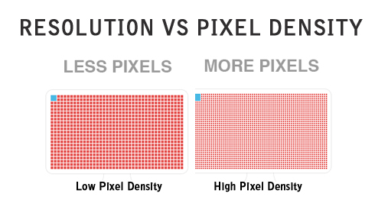](http://teknosrc.com/wp-content/uploads/2013/12/High-Pixel-Density-Vs-Low-Pixel-Density.jpg)

High Pixel Density Vs Low Pixel Density

Pixel Density for Full-HD TV

      Consider we have a **Full-HD TV** with size 32 inches and resolution of 1080p (1920×1080 pixels). For the given specification, the pixel density comes to around **68.84 ppi**.

**E.g. Pixel Density = Root((1920^2)+(1080^2))/32=68.84 ppi**

Pixel Density for Nexus 5(Full HD Display)

      Consider we have a **Nexus 5** smartphone which has a 4.95 inch Full-HD display. For this smartphone, the pixel density comes to **445 ppi**.

      Nexus 5 has better pixel density(more than 6 times of 32 inch TV). Does this mean that Nexus has better quality display. Yes, the smartphone do have better Pixel Density.But we cannot actually compare display of the smartphones with big 32 inch TV because the applications and usage are completely different.

What makes the smartphones to be built with higher pixel density than TVs or monitors?

      Televisions are gadgets which we see from a certain display, say 7 or 8 feet. When we are seeing a 32inch Full-HD display in a distance of 7 to 8 feet, we will feel great sharpness and clarity. If we go near the display, may be one feet near the display, we may find degradation in the quality of the image. TV displays are designed in such a way to see it with certain distance. i.e. we can see the content on the display pixellated. The human eye cannot see the individual pixels if the human is viewing the display from 3 to 4 feet distance.

      Consider in the case of smartphones, they are designed to use in just 1 to 2 feet distance. So we can feel greater sharpness only if the display has higher pixel density. So it is mandatory to manufacture smartphones with higher pixel density compared to televisions.

# How to Understand Pixels, Resolution, and Resize Your Images in Photoshop Correctly

A Post By: [Ana Mireles](https://digital-photography-school.com/author/ana-mireles/)

Size, resolution, and formats… What do pixels have to do with it?

Do you buy your camera based on its number of megapixels? Are you having problems sharing your photos online? Does your print look low quality even if it looks great on the screen? There seems to be a lot of confusion between pixels and bytes (image size and file size), quality and quantity, size, and resolution.

So let’s review some basics to make your life easier, your workflow more efficient, and your images the correct size for the intended usage.

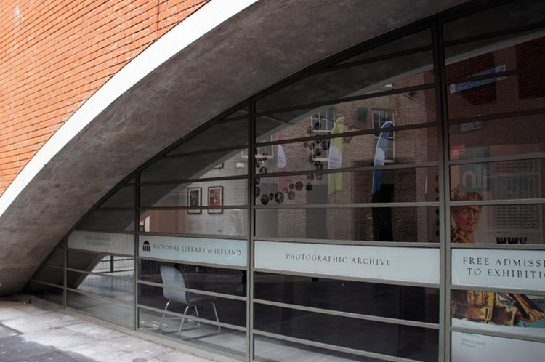

This image is sized to 750×500 pixels at 72 dpi, saved as a compressed JPG which is 174kb. Let’s look at what all that means.

## Is resolution the same as size?

One of the biggest misunderstandings comes from the concept of resolution. If this is your case, believe me you’re not alone.

The problem is that resolution can refer to many things, two of them relate to the problem at hand. Further on I’ll explain these two resolution concepts, however, they have one thing in common that I need to clarify first. They both have to do with pixels.

You’ve probably heard a lot about pixels, at least when you bought your camera. This is one of the most available and “valued” specs on the market so I’ll start there.

## What is a pixel?

A digital photo is not one non-dividable thing. If you zoom in far enough you’ll see that your image is like a mosaic formed by small tiles, which in photography are called pixels.



The amount of these pixels and the way they are distributed are the two factors that you need to consider to understand resolution.

## Pixel count

The first kind of resolution refers to the pixel count which is the number of pixels that form your photo. In order to calculate this resolution you just use the same formula you would use for the area of any rectangle; multiply the length by the height. For example, if you have a photo that has 4,500 pixels on the horizontal side, and 3,000 on the vertical size it gives you a total of 13,500,000. Because this number is very unpractical to use, you can just divide it by a million to convert it into megapixels. So 13,500,000 / 1,000000 = 13.5 Megapixels.

## Pixel density

The other kind of resolution is about how you distribute the total amount of pixels that you have, which is commonly referred as pixel density.

Now, the resolution is expressed in dpi (or ppi), which is the acronym for dots (or pixels) per inch. So, if you see 72 dpi it means that the image will have 72 pixels per inch; if you see 300 dpi means 300 pixels per inch, and so on.

The final size of your image depends on the resolution that you choose. If an image is 4500 x 3000 pixels it means that it will print at 15 x 10 inches if you set the resolution to 300 dpi, but it will be 62.5 x 41.6 inches at 72 dpi. While the size of your print does change, you are not resizing your photo (image file), you are just reorganizing the existing pixels.

Imagine a rubber band, you can stretch it or shrink it but you’re not changing the composition of the band, you’re not adding or cutting any of the rubber.

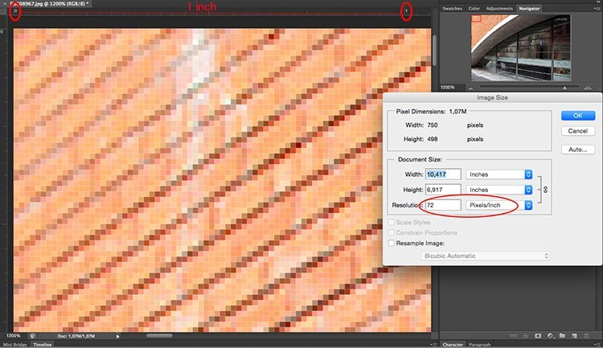

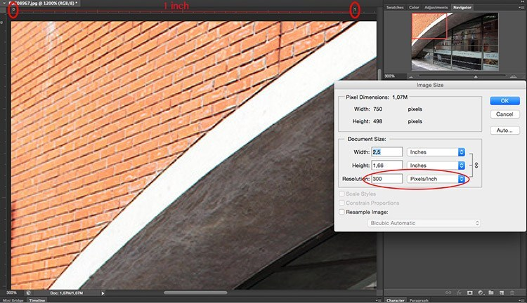

In summary, no resolution is not the same as size, but they are related.

## So quantity equals quality?

Because of the aforementioned correlation between size and resolution, a lot of people think that megapixels equal quality. And in a sense it does because the more pixels you have to spread out, the higher the pixel density will be.

However, on top of the quantity you should also consider the depth of the pixels, this is what determines the amount of tonal values that your image will have. In other words it is the number of colors per pixel. For example, a 2-bit depth can store only black, white and two shades of grey, but the more common value is 8-bit. The values grows exponentially so for example with an [8-bit photo](https://digital-photography-school.com/16-bit-vs-32-bit-vs-64-bit-what-does-it-all-mean/) (2 to the power of 8 = 256) you’ll have 256 tones of green, 256 tones of blue, and 256 tones of red, which means about 16 million colors.

This is already more that the eye can distinguish which means that 16-bit or 32-bit will look relatively similar to us. Of course, this means that your image will be heavier even of the size is the same, because there is more information contained in each pixel. This is also why quality and quantity are not necessarily the same.

Therefore quantity helps, but also the size and depth of each pixel determine the quality. This is why you should look all the specs of the camera and its sensor and not just the amount of Megapixels. After all, there’s a limit to the size you can print or view your image, more than that it will only result in extra file size (megabytes) and no impact in the image size (megapixels) or the quality.

## How to choose and control image size and file size?

First of all, you need to choose the outlet for your photo, there is a maximum density that you need. If you are going to post your image online you can do great with only 72 dpi, but that is too little for printing a photo. If you are going to print it you need between 300 and 350 dpi.

Of course, we are talking about generalizations because each monitor and each printer will have slightly different resolutions as well. For example, if you want to print your photo to 8×10 inches you need your image to have 300dpi x 8″ = 2400 pixels by 300dpi x 10″ = 3000 pixels (so 2400×3000 to print an 8×10 at 300dpi). Anything bigger than that will only be taking up space on your hard drive.

## How to resize in Photoshop

Open the menu for the image size and in the popup window, you need to tick the Resample Image box. If you don’t activate “resample” you will only be redistributing the pixels like I explained at the beginning of the article.

You can also choose to tick the Constrain Proportion if you want the measure to adjust according to the changes you make. So the width adjusts when you change the height and vice versa.

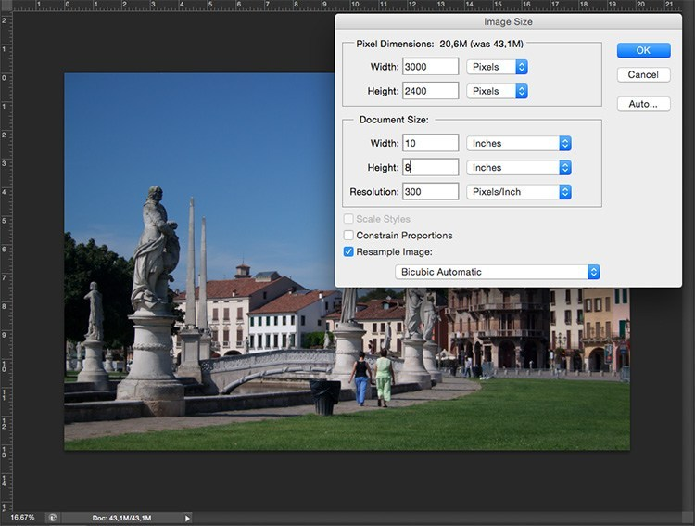

8×10 inches at 300 ppi, this is the size needed for printing an 8×10. Notice the pixel size is 3000 x 2400.

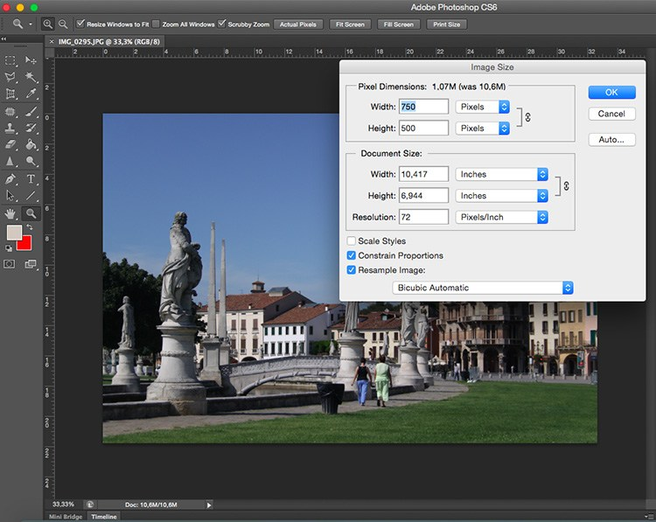

750×500 pixels at 72 ppi. This is web resolution and is the exact size of all the images in this article. The size in inches is irrelevant when posting online – only the pixel size matters.

On the top of the window, you’ll also see how the file size changes. This is an uncompressed version of your image, it’s the direct relationship I explained in the first part of the article: fewer pixels means less information.

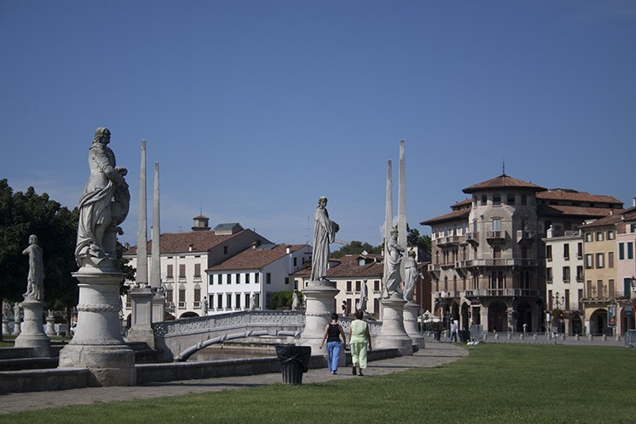

Now, if you still want to change the file size without resizing anymore, you have to do it when you save the image. Before saving your photo you can choose the format you want:

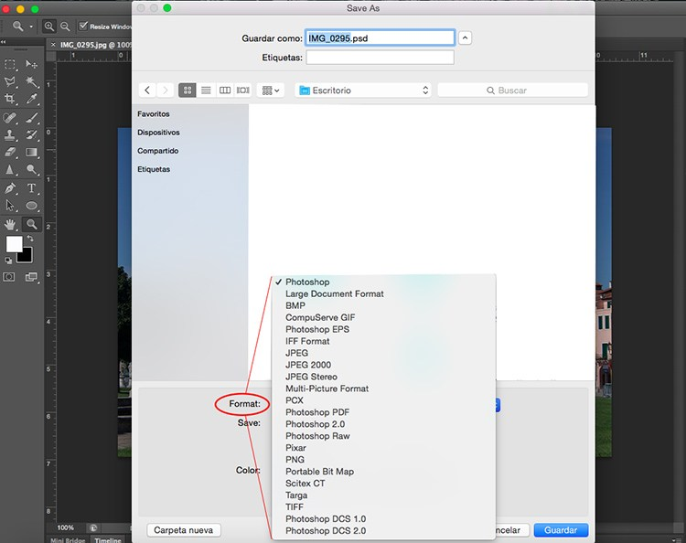

If you don’t want to loose any information you need to save an uncompressed format. The most common, and therefore easier to share is TIFF.

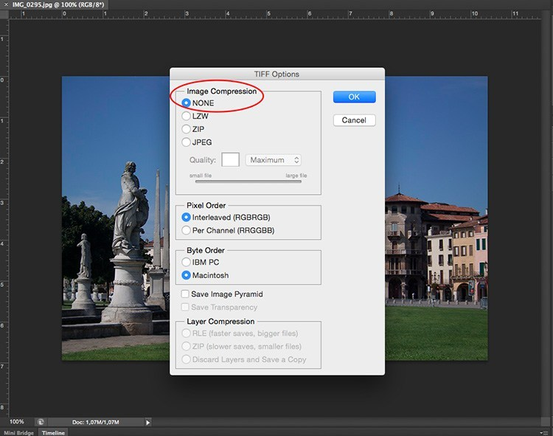

If you don’t mind losing a little information as long as you have a lighter file, then go for a JPEG and choose how small you want it. Obviously the smaller you set it, the more information you will lose. Fortunately, it has a preview button so you can see the impact of your compression.

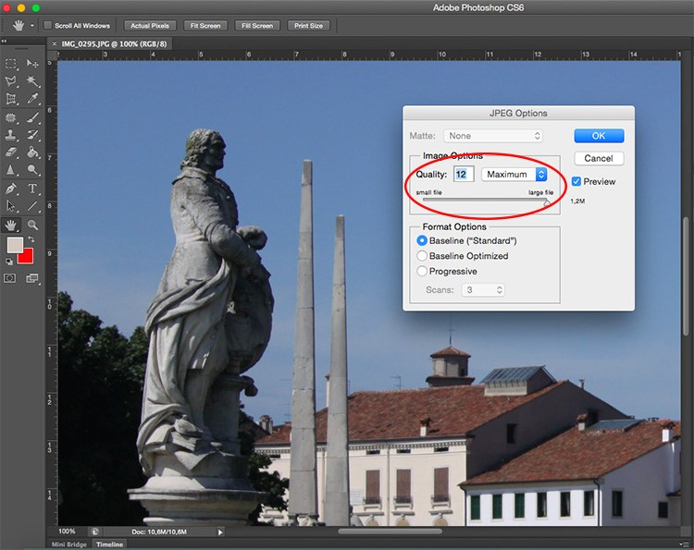

JPG high quality.

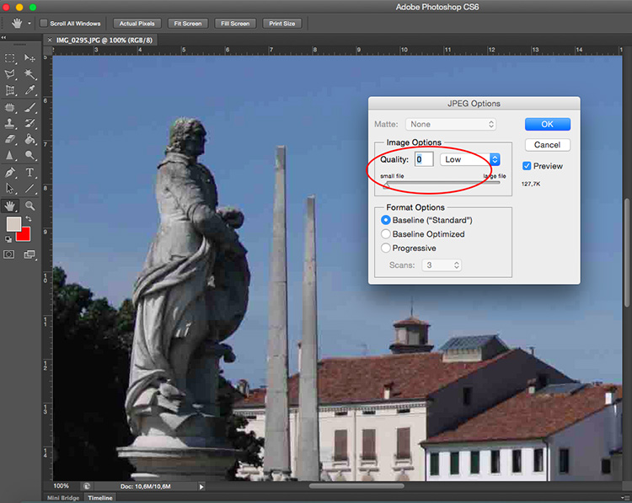

JPG low quality. Notice how it’s pixelated and breaking down? If you crunch it too much or go too low quality you risk degrading the image too far.

## Conclusion

So there you have it. So quality, quantity, size and resolution explained and they all have to do with pixels, as they are the basic units that constitute your image. Now that you know you can make the best choices to print, share and save your photos.

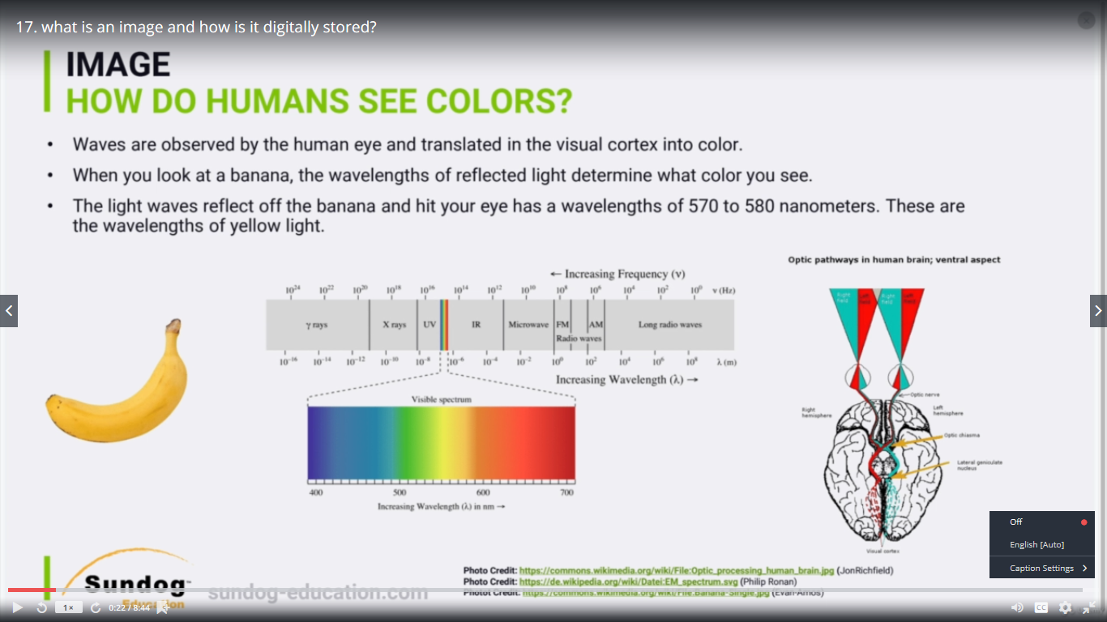

We want to learn how can how do humans see colors in general.

So let's assume that we have the banana and we want to see like OK how humans you know with a set of

eyes for example and with the brain can see the color yellow for instance.

All right.

So in general what happened is when light is reflected across that banana OK the wavelengths of the

light reflected is within that range.

OK.

That's pretty much the range of some of the wavelength of the light reflected through our eyes.

OK.

And that's kind of the visible spectrum that we could that humans could see.

So you guys can see here from 400 nanometres to around 700.

That's kind of the colors ranging from Blue moving forward to green yellow red and so on since we like

kind of you know in here for the yellow color you know which of the banana that was between five hundred

and seventy two five hundred and eighty nanometres.

All right.

So simply there are light waves that reflected off the banana and hit our eye.

Has wavelength from 570 to 580.

And that's kind of the wavelength of the yellow light.

All right.

And that yellow lights simply or this image is sent through our optic nerve and then translating our

version on our visual cortex as you know as a colored yellow color red or whatever.

All right.

And that's pretty much how humans see color.

And right now what we're really interested in how can we represent an image in a digital format.

